How to get your FRN number

Go to
https://apps.fcc.gov/cores/userLogin.do
and this page pops up
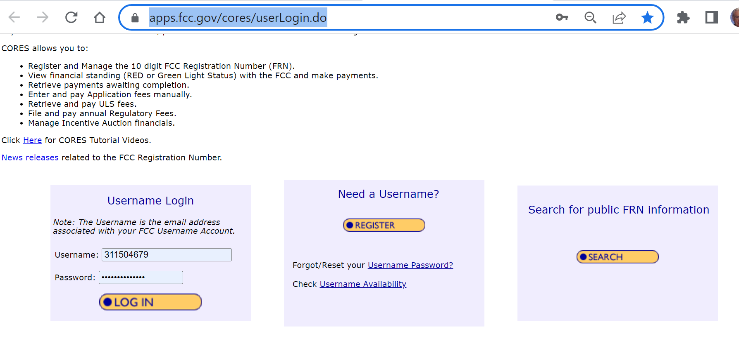
Click on Register and you get the Create New Account display

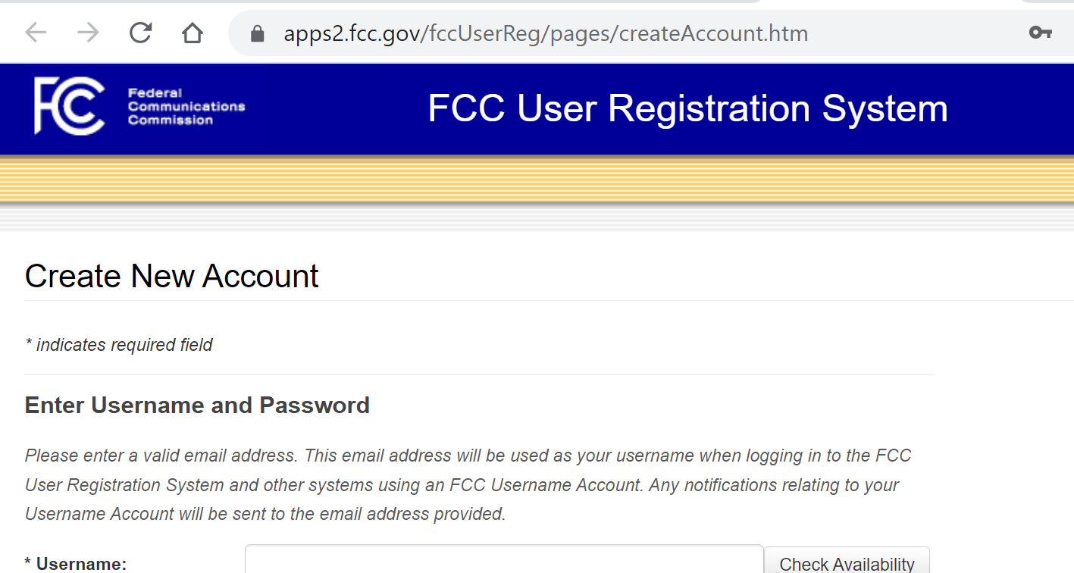

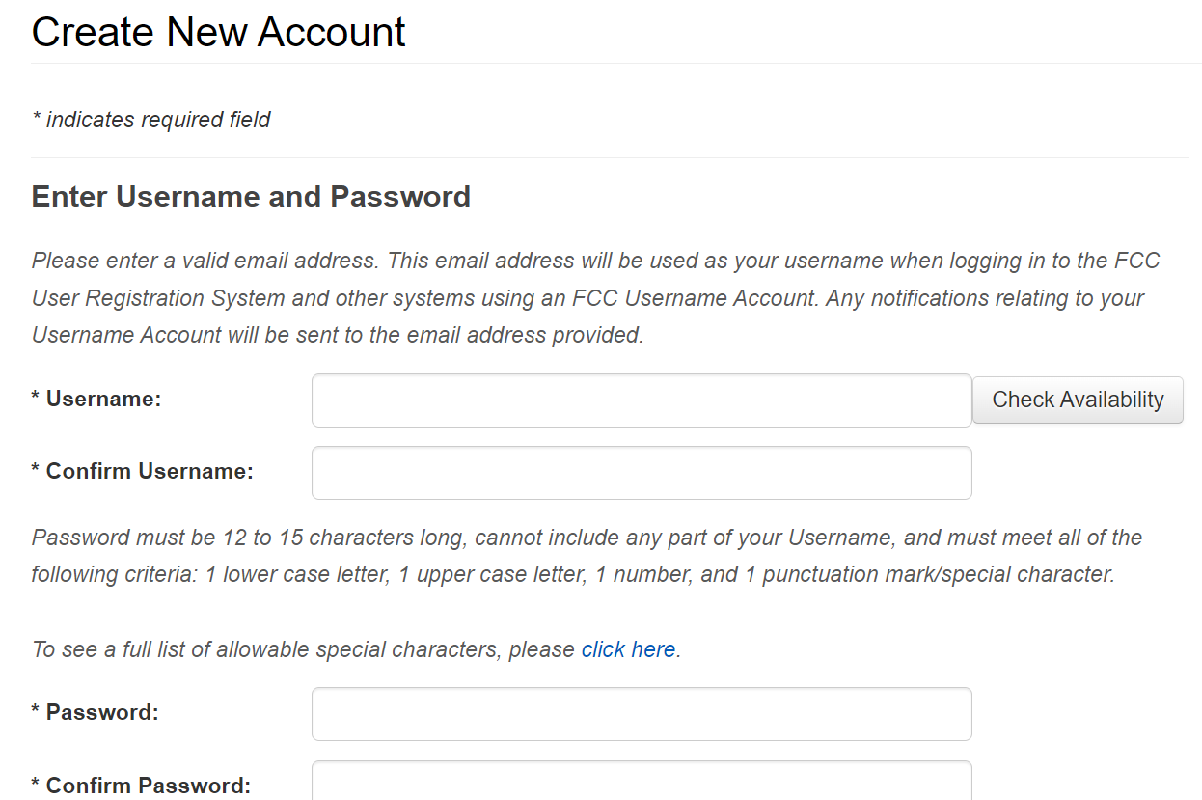
Enter your email for user name, and read the requirements for password carefully before entering and confirming a password.

Then do the “Enter Security Section”

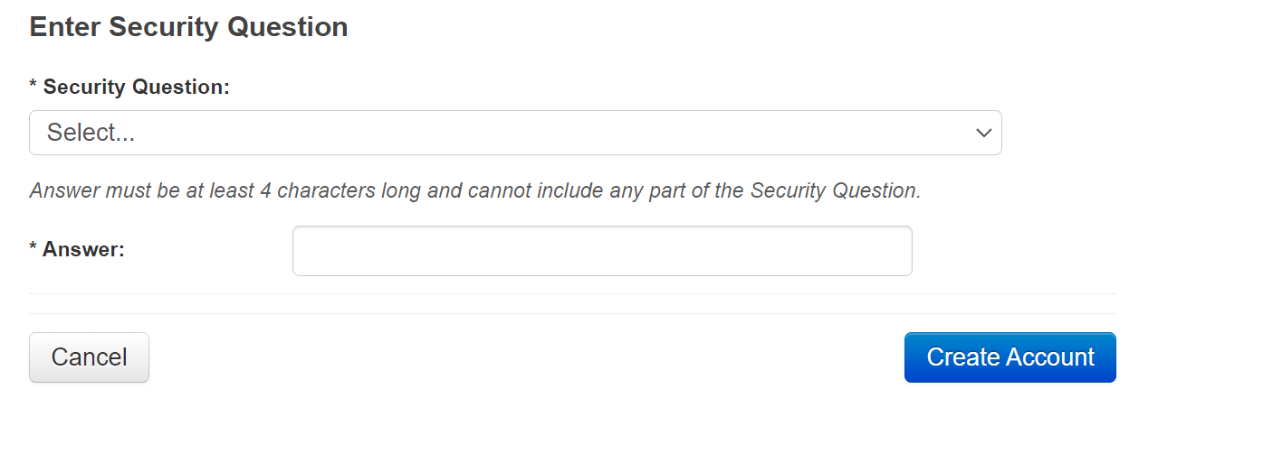
… and then click on Create account

You should now get a response that you’re account has been created and you should also be given an FRN number vendor registration number.
Above all else write down your username, Security question and answer, your password, and your FRN number. The FRN number is much like your Social Security number … hang on to it, you will need it often when you are communicating with the FCC.
