How To Program The Baofeng UV-5R Hand Held Radio With And Without A Computer
By
Bob Burkett K5DCZ
And
Edward Coyle KFDTL
Royal Gorge Amateur Radio Club
July 6, 2022
TABLE OF CONTENTS

- Introduction 3
- Why We Need Repeaters 4
- How Do Repeaters Work 4
- How Do Find a List of Repeaters 5
- The Big Picture 7
- Navigating the Menu editor 9
- The Menu of 40 Options 10
- The Big Picture of Programming 11
- OFFSET … Menu 26 12
- SHIFT + - SFT-D … Menu 25 13
- DELETE …Menu 28 15
- PL Tone (CTCSS) … Menu 13 15
- Store to Memory Channel … Menu 27 16
- SCAN 19
- STEP SIZE 19
- Scanning 20
- Post Scan Stop Action 21
- SIMPLEX 21
- How to Set Up A Simplex Channel 21
- Two Meer Band Plan 25
- Reverse 25
- Name The Channel 27
- Program UV-5R With Computer 27
- Identifying COMM Port 28
- Download From Radio 30
- Let Chirp Find The Repeaters 30
- NOAA 35

BAOFENG UV-5R

- INTRODUCTION

The UV-5R is an almost unbelievably low-priced hand-held radio made for VHF/UHF communication … which has a multitude of programmable features.

The UV-5R can be programmed via a computer (with the proper interface cable and associated software package), and also by manual programming through the UR-5R keyboard/display.

For local use most users will program the UV-5R or have someone else program for them, for communications through a local repeater. This manual addresses the question: “How Do I Program the UV-5R When I Don’t Have My Computer, Cable and Software with Me?” Maybe you are on a business trip or vacation?

This manual addresses the issues of how to manually program the UV-5R, and also how to do it via a computer.

****Cautions About Using This Manual****

One of my favorite expressions is “I am no longer young enough to know everything…” This gives me an excuse for not attempting to explain all the bells and whistles of the UV-5R. This manual does not address most of the advanced features of the UV-5R.

There usually are many different ways to solve most problems. There are often different ways to program the UV-5R. But for best success, rather than be creative, first follow closely the methods and procedures written herein. There will be plenty of time to pursue other perfect effectively methods once you have a basic understanding of how to program the UV-5R. Follow me through this user guide, then go create whatever methods works best for you.

- Why we need repeaters

Limitations of Your UV-5R (an HT Handy Talkie radio)

The UV-5R is basically a line-of-sight radio, and it puts out only about 5 watts or less. Antenna height is a major factor in determining the maximum distance over which two HT radios can communicate. Curvature of the Earth dramatically affects line-of-sight distance. With a “flat earth” with no mountains, buildings, etc. between, HT radios

can communicate about 7 miles if the radios are both about 6 feet off the ground. Line of sight in miles is approximately equal to 1.23 times the square root of the height of the radio in feet. With a repeater at 200 feet of height, you can expect a maximum of about 50 miles between HT radios. Repeaters on a 5000 foot mountain can “see” about 100 miles in every direction. The International Space Station is about 240 miles above the surface of the earth and can see about 1250 miles to the horizon.
So going through a satellite to a radio, one can communicate up to approximately 2500 miles. So the higher your antenna the better.

- WHAT REPEATERS DO?
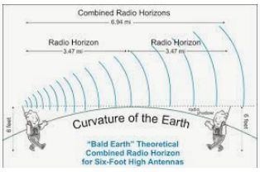
First off, repeaters have antennas that are quite high above ground…often more 200 feet high, usually on top of high-rise buildings, water than towers, mountains, etc. They run greater power than your hand-held UV-5R. Since they are high, they have a greater receiving range. The greater power gives them greater transmit output range.

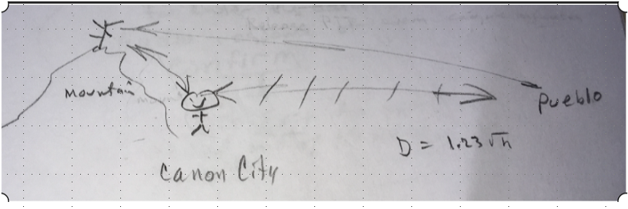

At the ground level I could not talk with someone in Pueblo, primarily because of the curvature of the earth. But, if both Pueblo and I can “hit the repeater”, which may be 40 or more miles apart, then we could talk with each other … primarily because of the height of the repeater on top of the mountain.

How Do I Find A List Of Repeaters?

There are many sources for repeaters:
- The ARRL Repeater Directory costs about $20 at ARRL or Amazon. It covers many of the different bands as well as Echo-Link, D-Star, IRLP, etc. It shows repeaters in the USA.

- RFinder $9.99 at www.rfinder.net Works on iPhone and Android devices. It shows repeaters worldwide.

- Google -- Just Googling “list of 2 meter radio repeaters in Houston, TX”, for example, yields a list of repeaters within a radius of 100 miles.

What Repeater Information Do I Get/Need to Enable Me to Program Those Repeaters Into the UV-5R?

Here is a typical repeater listing.

Location | Output/frequency | Input (Shift) | Notes (PLTone & CTCSS) | Call | Sponsor
Denton | 149.92 | -- | 110.9 | W5NGU | DCARA

The 146.92, is the output frequency of the repeater. Input -- is called shift. Notes 110.9, is called PL Tone and CTCSS. Under column labeled Call, W5NGU, is the call sign assigned to the repeater. Finally, Sponsor is the amateur radio club or agency sponsoring the repeater. In order to program the repeater into your UV-5R, use frequency, Shift, and PL Tone.

The Big Picture For Using A Repeater?

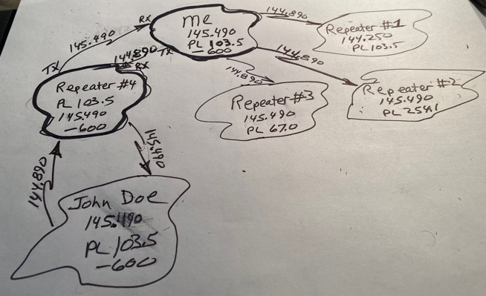
The drawing above shows four repeaters, 1, 2, 3, & 4. The frequency for each of these repeaters is set by Colorado Council of Amateur Radio Clubs, CCARA. Normally they would have different frequencies if they are close enough to interfere with each other.
The glob at the top of the drawing labeled ME is me and my UV-5R handheld. I have programmed it for Repeater #4 at a frequency 145.490 MHz, 103.5 Hz PL Tone, minus offset of 600 kHz.
Repeater #4 on the left side of the drawing which has an output frequency of 145.490 (in the 2 meter band) … a PL Tone (CTCSS) of 103.5 Hz … and is programmed to receive on a frequency 600 kHz below it’s output frequency.
Your transmit frequency will be the repeater’s output frequency which is your receive frequency, plus or minus the stated Shift (Offset ). Since ME in the above drawing uses a minus shift and an offset of .600 MHz, you will subtract the offset from the repeater’s output frequency … 145.900 minus .600 to get your transmit frequency of 145.490-.600 = 144.890. The top line on the display of your UV-5R will change to this 144.890 when you press the Push-to-Talk button, and change back to 145.490 when you release the button.
In the process of programming a channel you will need to set the frequency to 145.490, in Frequency Mode, before you input PL Tone, Offset, Offset Direction.
From the diagram above, only Repeater # 4 will respond to my 144.890 MHz signal … because repeaters #1, # 2 and # 3 are set up to receive signals with different PL Tones. Thus, while there might be several repeaters in the same local area using the same frequency, they do not interfere with each other.

Navigating the Menu
The key to manual programming of the UV-5R is to understand how to navigate its menu of programming options.
The sequence is:
- Press Menu button
- Make your choice of which menu option you want to edit
- Press Menu button again
- This takes you into your chosen option
- Do your editing
- Press Menu
- Voice says “confirmed” … meaning “I got it”
- Press Exit to get out of the menu
Use this same sequence of steps to edit each of the 40 Menu options.
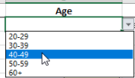
When you press the Menu button on the UV-5R, you are taken to a list of 40 choices of programming options … but, you can see only one of them. This is similar to but not the same as with computer dropdown boxes. With a computer you click the arrow and the box drops down with all the choices being shown.

The Baofeng menu shows only your last menu choice., i.e.one of the 40 options. In the picture below all 40 choices are available.

Menu of 40 Choices
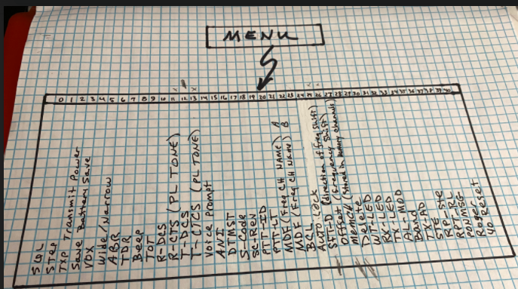
But you must key in the number of the choice you want to work on. You can also make the selection using the up and down arrows. Once you select the Menu choice, you can edit it’s details as outlined in the sections below.
You must clear a channel using Menu 28 before you will be able to store anything new into a channel.
There are only four items you must enter to program a channel … frequency, Offset (shift), Offset Direction (+ or – or Off), and PL Tone (CTCSS). The following sections illustrate how to enter each of these.

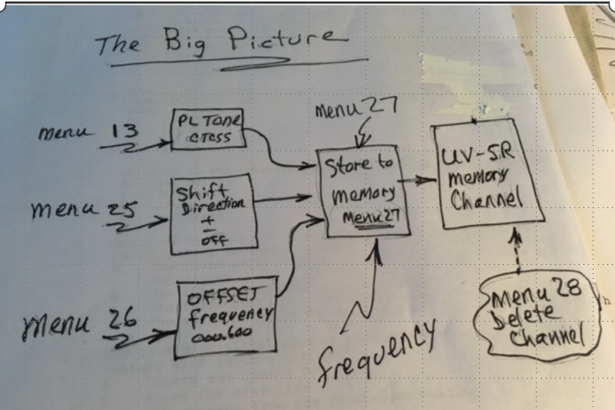
You will enter three of these parameters into what amounts to “Holding Registers” … you have the frequency on the display. When you use Menu 27, Store Memory, all four parameters get stored into whatever memory channel you choose.
You could enter the same parameters into another channel simply by doing another Menu 27 to another channel, since PL Tone, Offset, and Offset Direction are still in the “Holding Registers” … and changing the frequency in the display before doing the Menu 27 again.

Ok, how to do it …
When you are manually programming repeaters into channels, you will most frequently be using Menu options
- 13 PL Tone (CTCSS)
- 25 Shift Direction (+ -)
- 26 OFFSET
- 27 Store Memory
- 28 Delete Memory Channel

In all of the menu sequences below I put quotation marks around voice responses from the radio.

OFFSET MENU 26

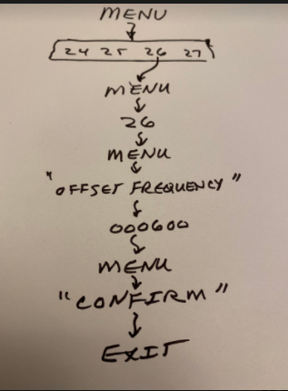
Press MENU to enter the Editor. Voice will say “MENU”

- Press 26 then MENU again. Voice will say “OFFSET FREQUENCY”. Arrow moves
to the bottom of the display indicating you are in the EDIT MODE.

- Key in the OFFSET. An Offset of 600 KHz would be entered as 000600 which would display as 000.600. You must enter the lead zeros/

- Press the MENU key. A voice will say “Confirm”
- Press EXIT to leave EDITOR

Offset is not the same everywhere in the 2-meter, or other bands.
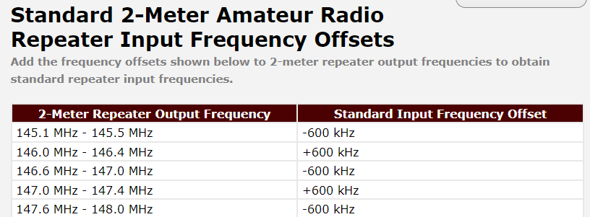
You can also set a password to serve as a gatekeeper for signals coming into you receiver.

_____________________________________________________________________________________

Shift +/- (SFT-D) Menu 2
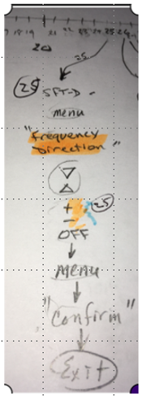
- Press the MENU button

- Use the up or down arrow buttons to select Menu 25. You can also enter 25
on the keyboard. The display will show SHF-D

Press MENU again. The voice will say “Frequency Direction”.

- The display will now show +, -, or OFF

- Use the up and down arrow keys to make your choice of the three options

- Press the Menu Key. A voice will say “Confirm”

- Press EXIT to exit the editor

_____________________________________________________________________________________

To delete a channel Menu 28

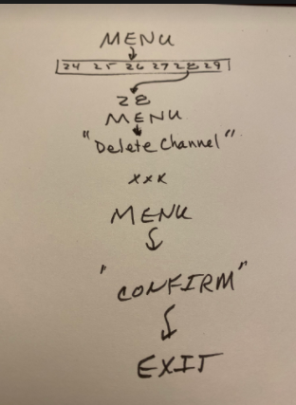
- Press MENU
- Voice Says “MENU”
- Key in 28
- Press MENU
- Voice says “Delete Channel”
Press Menu
Voice says “Confirm”
Press Exit

- Key in channel Number to be deleted. The channel number will show in the bottom row. If the number has a CH in front of it, the channel has something programmed into it. If the CH is not there, the channel is empty.

Enter PL Tone (CTCS)
Menu 13
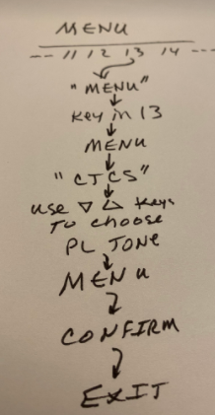
- Press MENU
- Voice says ”MENU”
- Key in 13
- Press MENU
- Voice says, “CTCS”
- Use up and down keys to choose PL Tone
- Press MENU
- Voice says, “Confirm”
- Press Exit

Remember that you can program channels only when you are in the Frequency mode … and that the arrow is pointing to the frequency in the top row. See the arrow at left end of the top row in the picture below.

You cannot program while in the Channel Mode.

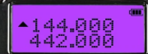

Save Channel (MEM-CH)

At this point you have already put on SHIFT {+/-}, OFFSET, and PL TONE…and the channel you are going to save to has been cleared, deleted, … and the arrow**is on the top row of the display. You are in frequency mode.
NOTE: These 3 parameters, SHIFT {+/-}, OFFSET and PL TONE (CTCSS) are sitting in 3 separate “registers”, awaiting further instructions.
***When you save to a channel, you are taking these three parameters and the repeater frequency and storing them into the chosen channel.
PL TONE, SHIFT and OFFSET will remain in these “registers” after you complete this SAVE operation—remaining there until you change them. So, you can use them again.
Here is an example of the typical information listed in AARL Repeater Directory, RFinder or other sources.
Location | Output/frequency | Input (Shift) | Notes (PLTone & CTCSS) | Call | Sponsor
Denton | 146.920 | - | 110.9 | W5NGU | DCARA

The 146.920 is the repeater’s output frequency … which becomes your Receive frequency. This is the frequency you will enter as you program this repeater into a channel.
Your transmit frequency will be this frequency plus or minus the Offset frequency, (most often 600 Hz for VHF repeaters}. Transmit frequency is automatically determined by the radio. When you push the PTT button the display will change to the output frequency while the button is pushed down.
The column labeled Input(Shift) above, the minus (-), is referred to as PLTone … also known as CTCSS, Continuous Tone Coded Squelch System. This is the key that unlocks the door to the repeater.
This PL Tone is transmitted as a “sub-audible” tone, it is usually below 300 Hz, you will not hear it, that rides on your output signal any time you turn the transmitter on.
This PLTone also serves as a squelch (PASSWORD). This PLTONE should be the same one as the repeater is set up to receive on. Of all the repeaters in your area that receive your signal with this PLTONE only the one with a matching PL TONE will open up.

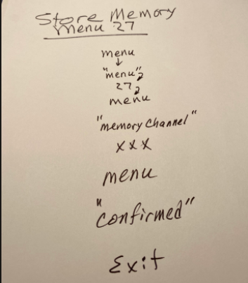
Press Menu
Voice response of “Menu”
Press 27
Press Menu
Voice response of “Memory Channel”
Enter number of the channel (three numbers)
Press Menu
Voice response of “Confirmed”
Press Exit

Go check it out. Select the channel you just programmed. Push and release the PTT button. You should hear the repeater come back to you with a green light and a signal strength indicator across the bottom of the screen along with an audible response. You want to do this with a repeater you know to be within range. If this does not happen, check over your programming steps again.
******************************************************************************

Scanner

The UV-5R has a built in scanner for VHF and UHF bands. When on Frequency Mode (VFO mode) it will scan from repeater to repeater in steps according to the Frequency Step which you can program using steps below.

STEPSIZE Menu 1

Set the STEPSIZE as follows:
While in VFO Mode, Press MENU 1 Voice will say “MENU”
Display will show STEP 5.0K This number may vary.
Press MENU again. Voice will Say “Frequency Step”
Press the up down arrows xx to select the STEPSIZE you desire from the table below.

Key | Values (kHz) | Notes | Default value
0 | 2.5K |  | 25.0K
1 | 5.0K
2 | 6.25K
3 | 10.0K
4 | 12.5K
5 | 25.0K

Press Menu after making your STEPSIZE selection. Voice will say “confirm”.
Press EXIT to get out of the MENU.

This STEPSIZE will be used by the SCANNER function. STEPSIZE tells the SCANNER the increment (increase or decrease) in frequency in KHz as it moves from sampling one frequency up or down looking for the next active QSO.

CAUTION !!

The scanner can step over an active frequency and miss it. Consider two repeaters at 146.7600 and 146.800. If you were scanning in steps of 50.0K, you could hit one and miss the other.
146.7600
+ .0500
146.8100 Misses 146.800
SCANNING

With STEPSIZE entered we can now illustrate how scanning works. The idea is to determine which channels are active (someone is talking on) without you having to sit there and push the up/down arrows to move from one channel to the next.

Suppose you just flew into New York City with your UV-5R, and you want to know what frequencies are active. i.e. find frequencies with active QSO’s ongoing. Turn on the scanner and let it find them for you.

If you are in CHANNEL MODE, it will scan only your channels. (the ones you programmed into your UV-5R). If you are in Frequency Mode (VFO), the scan operation will start at the beginning of the band and scan upward in steps equal to the STEPSIZE you entered in MENU 1. When it moves to an active channel (i.e. it hears a conversation going on) it will stop. You will hear the QSO in progress.

Menu 18 Set Scan Follow-up (What to do after scan stops on an active channel)

You have three options for instructions on what to do next. The three options are:

- TO --Time Operation--resume scan after a fixed time interval

- CO -- Carrier Operation--resume scan after the active signal disappears

- SE -- Search Operation--scanning stops when it detects a signal

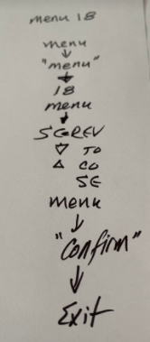

If you just want to hear which channel of your programmed channels is active, initiate the scan sequence in the Channel Mode.

To scan the outside world, start the scan from the Frequency Mode (VFO).

SIMPLEX

With a flat bald earth surface, no mountains, buildings, etc in between, the distance out to the horizon is about 3.5 miles because of the curvature of the earth. If two stations are using Simplex, they can be up to about 7 miles apart

In order not to monopolize a repeater with a long QSO, it is good to go off frequency… to one of your pre-programed SIMPLEX frequencies where longer QSO’s are welcome. It is generally a good idea to program several SIMPLEX frequencies into Memory Channels.

Simplex means no PL Tone, no Offset, Shift Direction is set to OFF

Menu 26 | OFFSET to 00.000 | OFFSET
Menu 25 | SFT-D to OFF | SHIFT
Menu 13 | T-CTCS to OFF | PL Tone
Menu 11 | R-CTCS to OFF | PL Tone

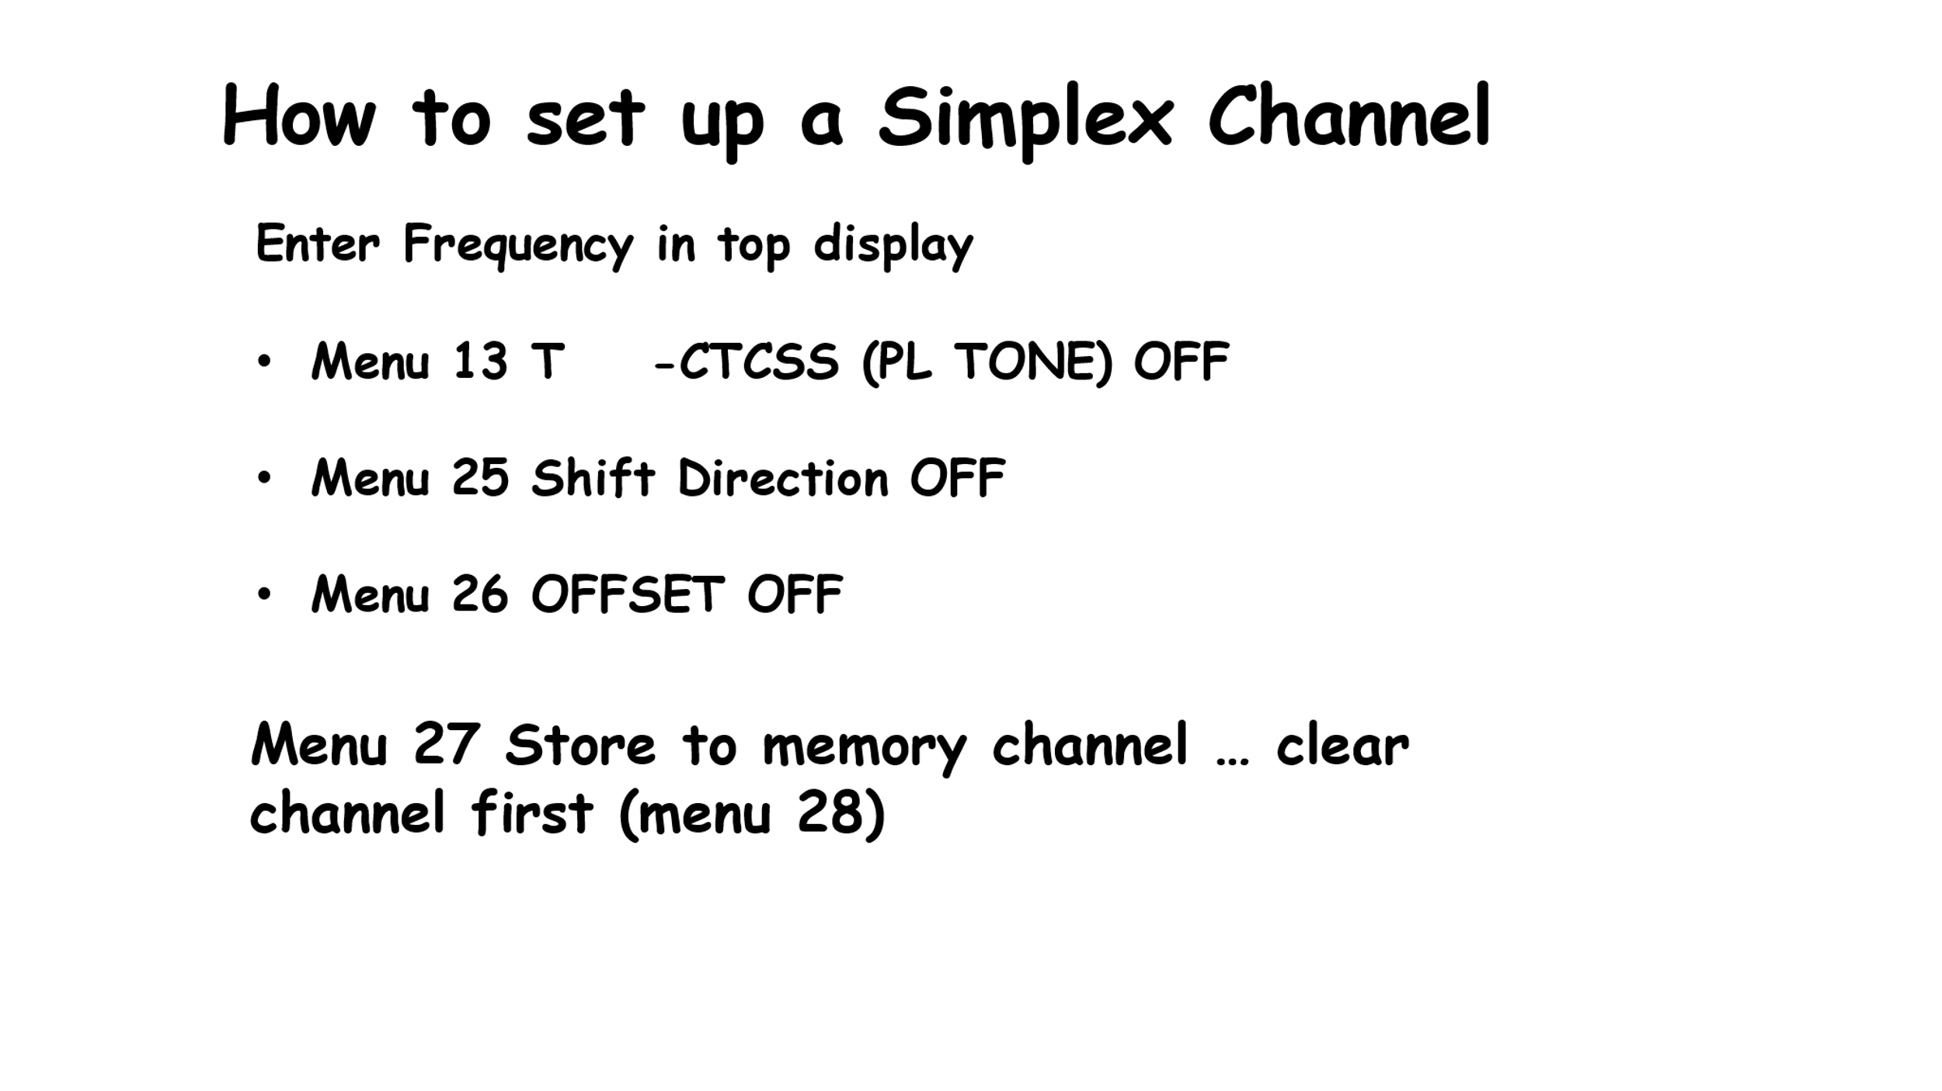

If we are close enough to each other, a repeater may not be needed. Under this situation we can bypass the repeater and talk directly radio to radio, HT to HT. You do not want to jump on just any frequency lest you step on a repeater. You want to use one of the SIMPLEX frequencies… ones set aside by local coordinators.

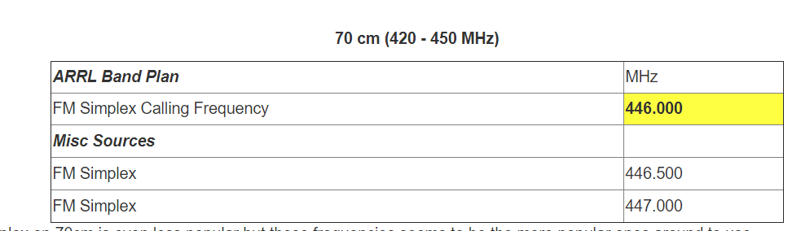
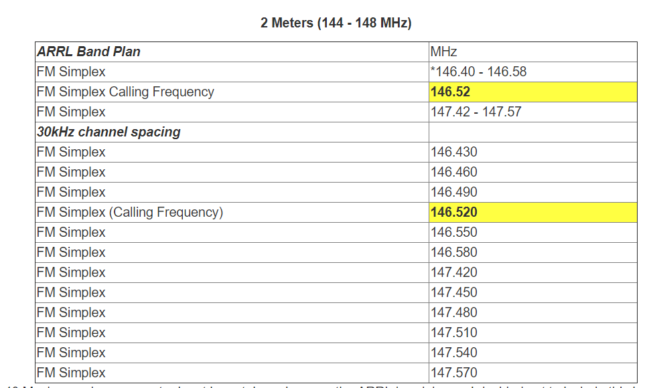

Notice in the above table “FM Simplex” is shown as a range of frequencies while others are specific frequencies.

Note further the National Simplex Calling Frequency is 146.520.
Once you have established contact on the National Calling Frequency, move off to one of the Simplex frequencies,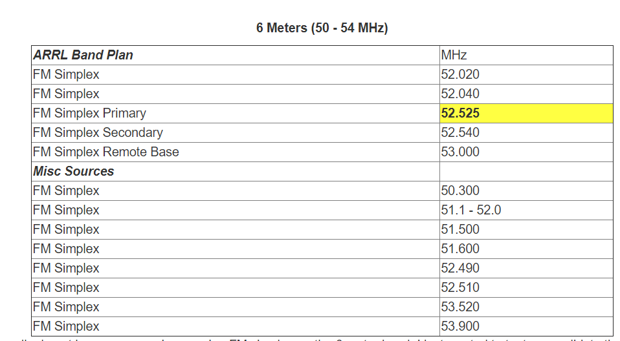

Remember to stay off the repeater input frequencies when using simplex. You may be keying the repeater up and creating interference to others, and you
will never know it when operating simplex unless someone hears your call sign and abruptly lets you know about it !!!.

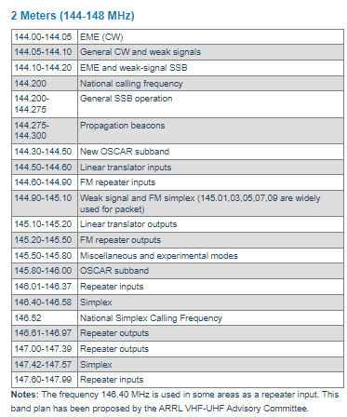
Stay away from those ranges of frequencies marked as FM Repeater Inputs and Outputs. (blue)
Stick with the green arrows for National Calling frequencies and simplex ranges of frequencies

I can hear you without the repeater… if you can hear me, let’s switch to simplex? We can leave this Calling Frequency, 146,52 and go to a simplex frequency … how about we go to 147.420 or to another of the simplex frequencies.

Reverse
How do I know if we can hear each other without the repeater, i.e., could we go to simplex?
Baofeng radios have a function called Reverse which allows you to see if you can hear the other party without the repeater.

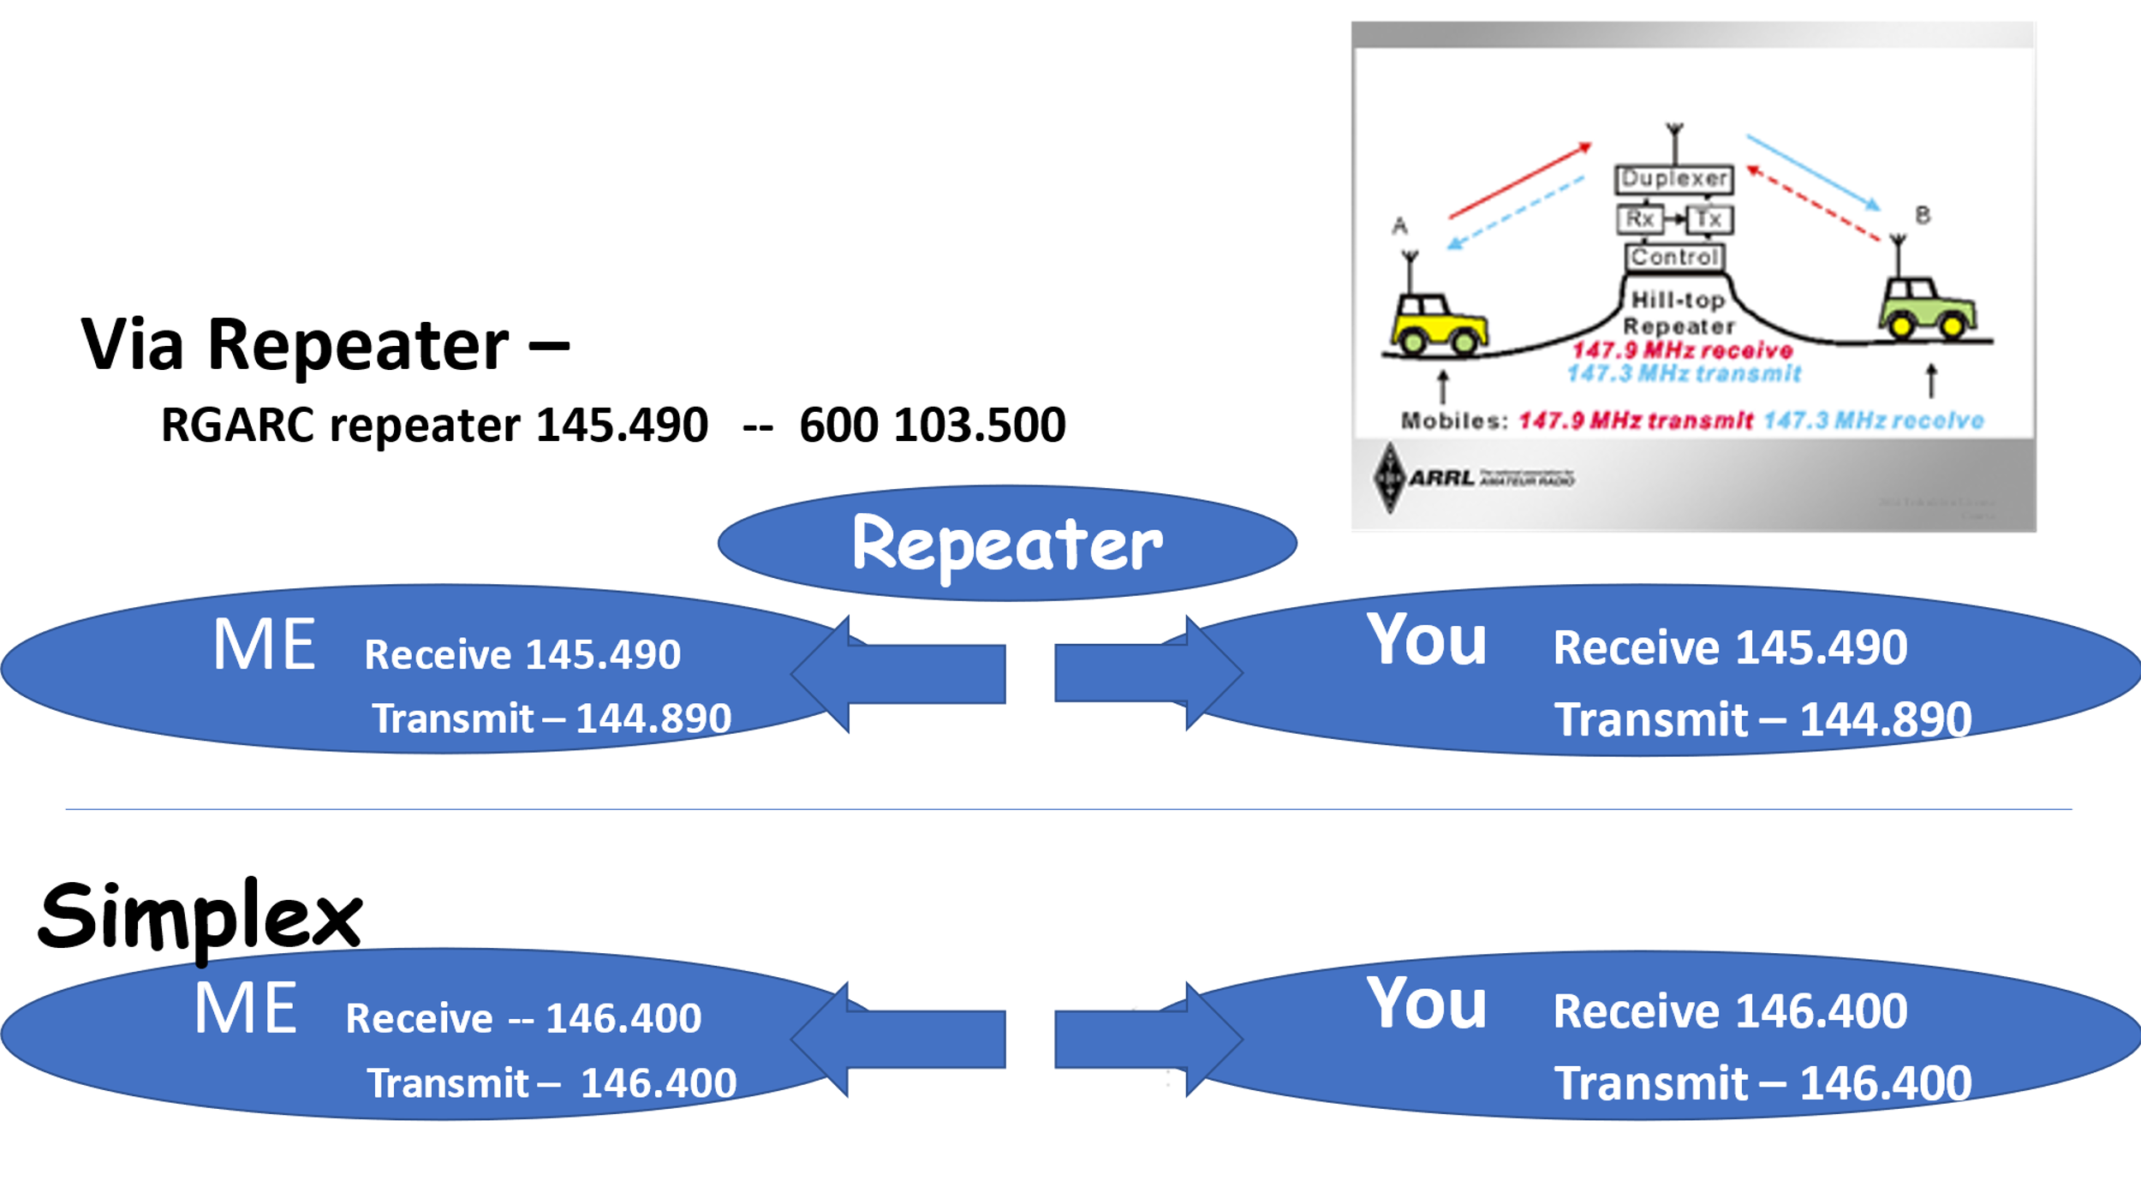

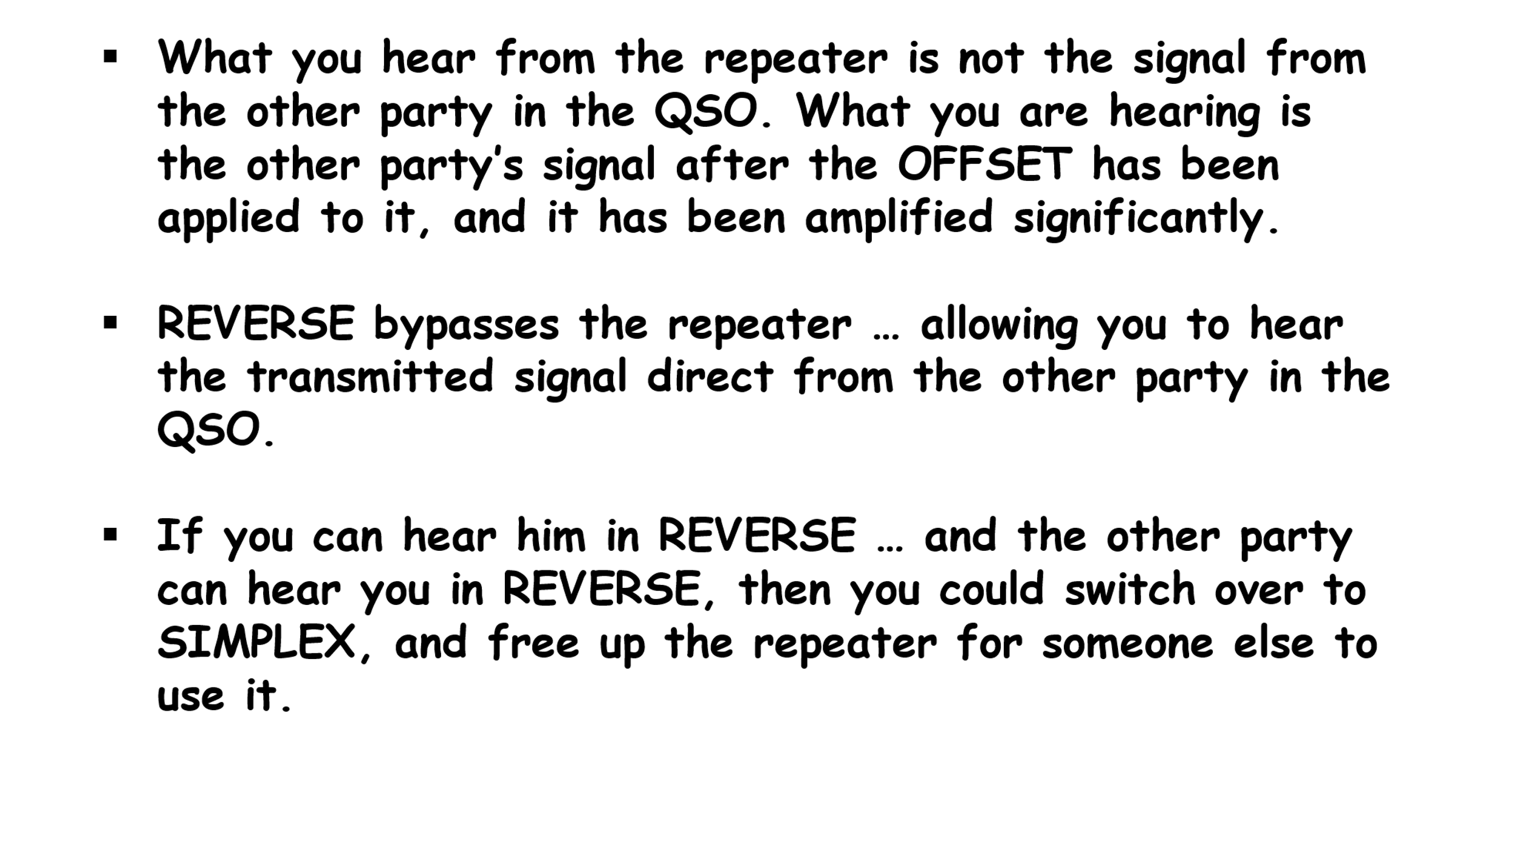
So, how do I do a reverse check?
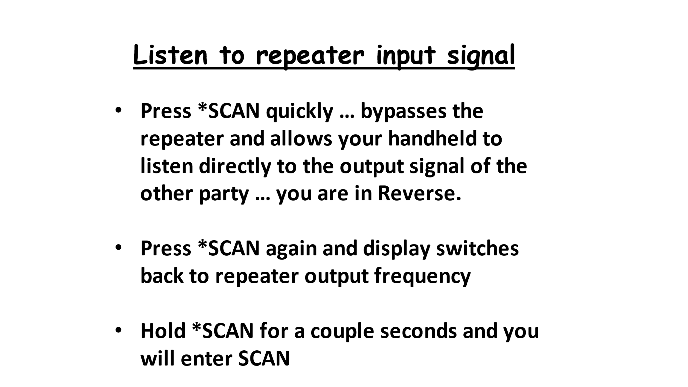

Putting a name on the channels
The name field will accept up to seven characters. You set up to display name in the display with Menu 20 and 21.

Program UV-5R Using a Computer

Manually programming a new repeater into your radio is pretty straight-forward…once you understand the procedures outlined in the preceding sections of this user guide. However, if you are entering several repeaters, or just want a hard copy of what you have in the radio, it is easier to use a computer and its software to do the programing. A la “spreadsheet style”.

There are several software packages that do this: RT Systems about $40; CHIRP $0 free
CHIRP is probably the most widely used since it is free.

For this discussion, we will use CHIRP. The interconnecting cable between the computer and the radio is critical. The cable has a pod on the USB end that has a microprocessor chip specifically programmed to work with the UV-5R. Not all cables are equal. Some cables on the market simply will not work. Buy the cable from a reputable source, such as Amazon for about $10.00 or more.

You must tell CHIRP which USB port you plug the cable into. You can make this determination by plugging the cable into one of the USB ports…then “looking” into the computer Device Manager. With Windows 10, right mouse click on the START icon on lower left corner of screen (left end of the Taskbar). Select DEVICE MANAGER and left mouse click it. Up pops the DEVICE MANAGER. With DEVICE MANAGER open on the computer screen, plug in the cable. You will notice the screen flickers a bit, and about half-way down the list, a new item begins to show in the list. It is titled PORTS (COM+LPT). If you left mouse click it you will see, “Prolific USB-to-Serial Comm Port (Com#)”. The # will show the port number. If you plug the cable into another USB connector, the DEVICE MANAGER screen will pop back up with the same identifier message. However, the # will change to show the port number identification for that port. Some times it will show as “USB Serial Port (Com #)”

You can use whichever port you want, but you must tell CHIRP which one you want to use. More on that later.
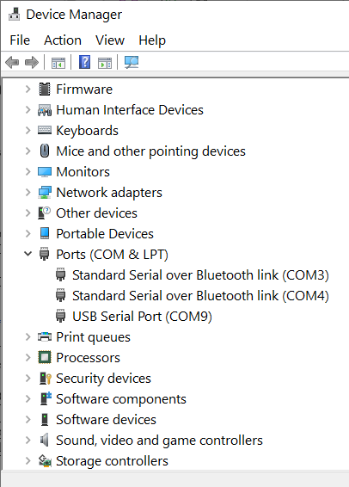
The arrow above says I am plugged into Com Port 9

With other versions of Windows Operating Systems, a similar procedure will bring up the CONTROL PANEL. Once it is open click on DEVICE MANAGER.

Now that you have the right cable, and know the USB port identifier, you are ready to move on the CHIRP. CHIRP is free for download at http://chirp.danplanet.com/projects/chirp/wiki/home
CLICK Download CHIRP for your platform”
CLICK Download the latest Windows Version
CLICK CHIRP-daily-20160329-installer.exe (This will vary depending on the day you are trying to download) The wide green line identifies the latest version … download this one.

The program will download to your Downloads Folder. Click on bottom right corner VIEW DOWNLOADS. Your download will be listed at the top of the list. CLICK on it and it will proceed to install CHIRP on your computer.

When CHIRP first opens you will see a blank screen with a menu bar at the top

CHIRP FILE EDIT VIEW RADIO HELP

One of the first things you need to do is to DOWNLOAD FROM RADIO (drop down under the Radio choice on the menu bar above. Left mouse CLICK on RADIO and you will see the box below.

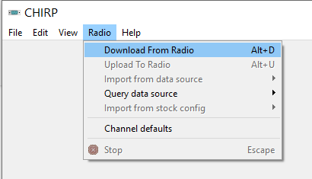

Click on Download From Radio. The box below pops up
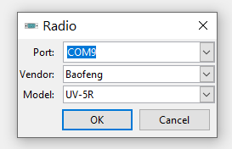

Here is where you use the Port number you identified with Device Manager. Click the dropdown arrow and select the port number. Select the vendor and radio model.

With this data entered, Click OK. Up pops a box Baofeng UV-5R instructions.

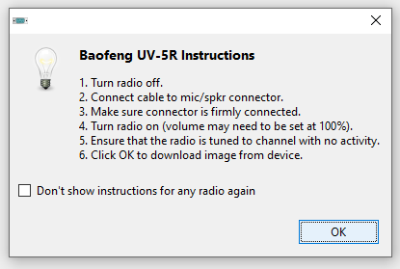

Follow the sequence and click OK and watch the show

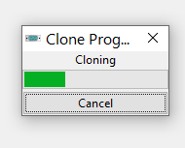
When it is done, the radio contents will show in a spreadsheet as below

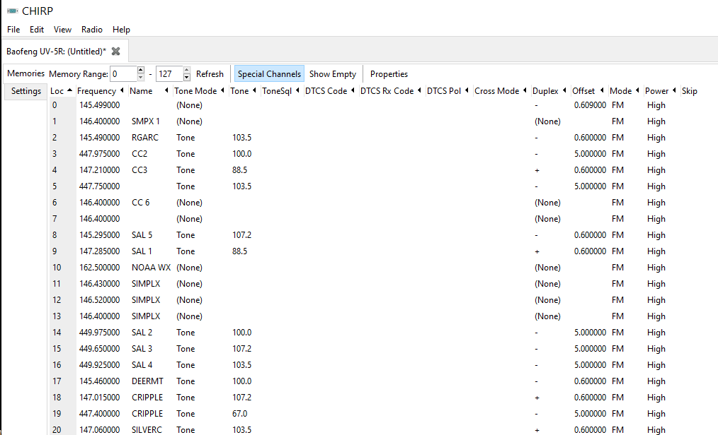

It is important to take note of MEMORY RANGE in upper left corner of screen. You may need to enter a START and a STOP to define the lower and upper limits of the block of memories (channels). The spreadsheet will display. You can program 128 channels. You can display any block of contiguous channels you choose.

Also take note of the SHOW EMPTY tab. This simply removes empty channels from the spreadsheet display with no impact on your radio.

In order to edit a channel, highlight the row, then CLICK on the particular field you want to edit. Right mouse clicking on a row brings up a dialog box with several options…much like Microsoft Excel.

Once you made changes, additions, deletions you can now upload it to the radio. Click on RADIO and select UPLOAD to radio. You will go through the same procedure as you did to Download from Radio to complete the upload of your spreadsheet to the radio.

You can now disconnect the cable…you have just programmed your UR-5R radio using the computer!

It is important to take note of the tabs at the top of the spreadsheet.

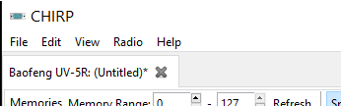
Note this spreadsheet is titled “Baofeng UV-5R (untitles”. If you were to download again from the radio ,an additional tab would show at the top. Problem is the spreadsheet which shows is the spreadsheet from the first download. To view the spreadsheet belonging to the second download you must click on the second tab at the top.

There are many different ways to search for repeaters … you can Google for them … you can use Repeater Book, and other sources. You can also let CHIRP search for them.
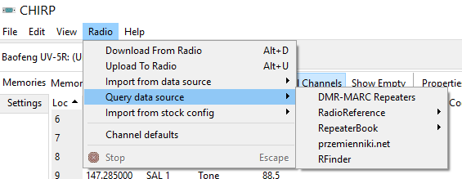
For example you can click on Radio … Query Data Source … Repeater Book …
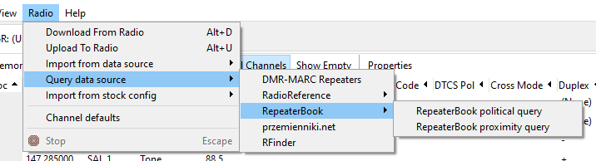

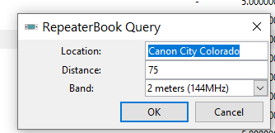
Step through this sequence and CHIRP will pull all the repeaters matching your search criteria into the spread sheet.

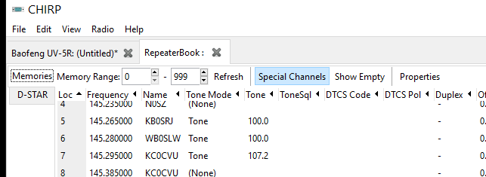
Note the tab at the top “Repeater Book” and this time the displayed spread sheet is the result of the search. This procedure is an easy way to get all the repeaters in any chosen geographic area. This is within a distance of your location.
Good Listening
Suppose you want to listen to NOAA Weather Service for your local area, and that you know they were on VHF at 162.500 … and that you did not have them programmed into your UV-5R. You could still listen to them by:
  - Going to frequency mode
  - Key in 162.500
NOAA Weather Radio broadcasts on the following frequencies across the country. 162.400 MHz. 162.425 MHz. 162.450 MHz. 162.475 MHz. 162.500 MHz. 162.525 MHz. 162.550 MHz.

FYI
You can find the call letters for all the ham operators by zip code by going to RadioReference.com. Click on databases, amateur radio database, and fill in the zip code. Currently this brings up 156 operators for zip code 81212 .

